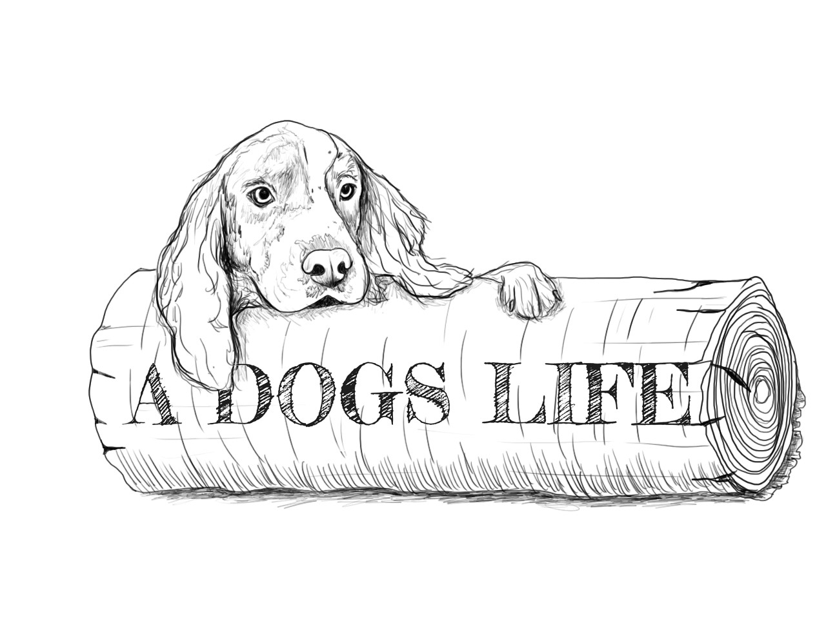

A Dogs Life pre‐screen questionnaire

Thank you for choosing our daycare, we strive to provide the best quality in dog daycare service including a healthy, calm, fun and sanitary atmosphere. Therefor we require our new clients to fill out the following information to help us gain some knowledge about your dog(s). In addition we would ask that you initial the rules and regulations to follow to ensure you have had the opportunity to read through the entire form. If you are registering more than one dog, please sign another copy of this form and fill one out for each individual dog.
- Owner name:
- Contact information: Address

Phone # Email

- Name of dog: Gender: Male Female

- Age of dog? Breed: Altered? Yes No Under 6 months
- How long have you owned your dog?
- Does your dog have any past or current medical issues or injuries we need to be aware of? Yes No If yes, please explain:

- Has your dog ever bitten or been aggressive with another dog? Yes No
- Has your dog ever bitten or been aggressive with a person? Yes No
- Does your dog like all people or select people? Yes No
- Have you and your dog had any formal training? Yes No
- Does your dog shown signs of resource guarding? (Toys, objects, people.) Yes No
- Has your dog been to an off leash park? Yes No
- Describe your dog’s energy level: Low Medium High
- Describe dog’s general behaviour & play styles:

- Does your dog get along with other dogs or ever play in a group setting? Yes No

- Does your dog recall well? Yes No
- Does your dog ever bark excessively? Yes No
- Does your dog show stress when you are not there? Yes No
- Why do you want to come to daycare?

- Please try and answer as clearly as possible. We are looking for a clear picture of how we can ensure your dog can have healthy play at our day care. Thank you.

Rules and Regulations

Thank you for choosing our day care. We are a very different day care in many ways. Please read below before submitting your application to ensure we are the right fit for you and your dog.

- We will redirect barking in a positive manner.
- Dogs are corrected with positive training re enforcement.
- If arousal levels get too high, we have several calming methods to use, as a last resort we will use one of our spacious holding pens for calming time.
- Please feed your dog’s prior to coming to daycare, the only reasons we can allow them to eat at daycare is if they are young puppies or if they are on a special diet.
- Please choose your attendance days and attend the same day(s) every week. Days can be booked a month in advance for shift workers. Routine is truly important for our dogs!
- After submitting required days, we would like you to attend a trial session to see if day care suits your dog.
- Your dog must have a collar in day care to ensure safety to themselves and others.
- A flea and tick treatment is HIGHLY RECOMMENDED at our daycare to ensure our dogs don’t transmit fleas and ticks to each other.

  - Just like school age children, it is unlikely but our dogs can get sandy, wet, and/or dirty at daycare depending on the weather/climate and what toys we have brought out to play with throughout the day . We will do our best to keep them as clean as possible!

I plan to bring my dog(s) on these days for day care.

Wednesday Friday

OFFICE USE ONLY

invoice # Processed by:

Date:

_ Date & time booked:

Client contact date:

