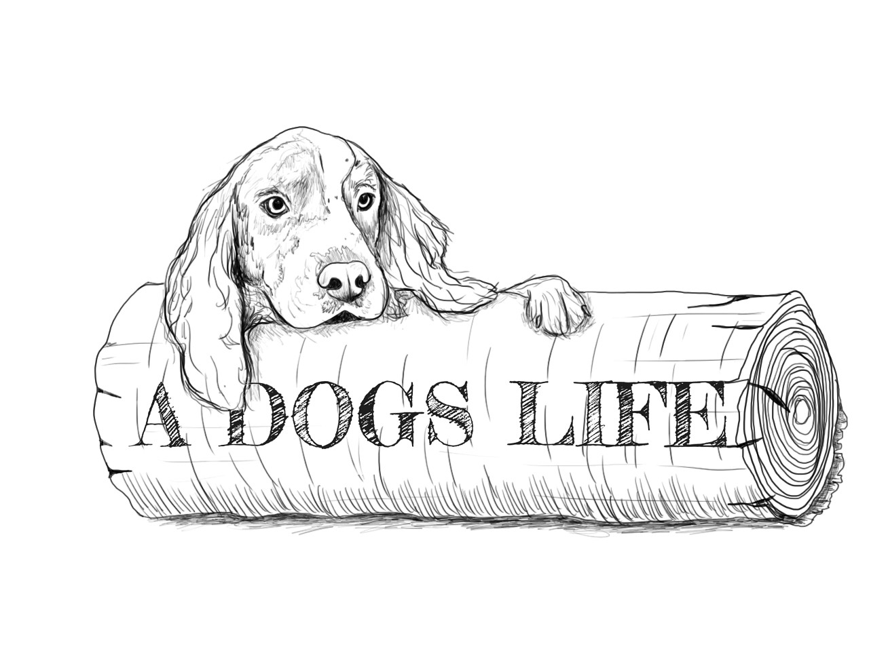
DOG DAYCARE WAIVER FORM
I understand that I am solely responsible for any harm caused by my dog(s) while my dog(s) is/are attending daycare at A Dogs Life.
I also understand and agree that in admitting my dog(s), A Dogs Life has relied upon my representation that my dog(s) is/are in good health and has/have not harmed or shown aggressive or threatening behavior towards any person or other dog.
I further understand that due to the way that dogs interact with one another, minor cuts and scratches can occur even though the dogs are carefully supervised at all times.
While my dog(s) is/are in the care and custody of A Dogs life, if I am unreachable in the event of an emergency, I hereby authorize A Dogs life, its agents, and/or representatives to seek immediate veterinary care for my dog. I understand that all costs in connection with, veterinary, medical or other treatment shall be my responsibility.
I hereby release and agree to save and hold harmless, A Dogs Life, it’s owners and employees from any and all liability, claims, suits, actions, loss, injury or damage of any nature or kind, or for any liability, claims, suits, actions, loss, injury or damage which I or my dog(s) may sustain or which may be caused in any way by my dog(s). I specifically, without limitation, agree to fully indemnify A Dogs Life for any and all such liability, claims, suits, actions, losses, injury or damage.
I certify that I have read and understand the rules and regulations set forth herein and that I have read and understand this agreement. I agree to abide by the rules and regulations and accept all the terms, conditions and statements of this agreement and confirm the truthfulness of the contents of the Application form completed by me.
Although we carefully screen all applicants, occasionally we discover that this is not an appropriate environment for every dog. A Dogs Life reserves the right to permanently remove a dog from daycare at any time.

DOG(S) NAME(S):

PRINT NAME OF OWNER: ____________________________________

SIGNITURE OF OWNER: ____________________________________ Date ______________

_

